Snowball Away Your Debt
The debt-snowball method helps you reduce debt by paying off accounts starting with the largest interest rate, while only paying minimum payments on other debts. Once the account with the largest interest rate is paid off, you proceed to the next biggest interest rate, adding the previous payment amount to the account as well. Continue to do this until you are debt free!
Snowball Explained
Debt | Collections | Store Credit Card | Medical Bill | Credit Card
Total Balance | $150 | $550 | $1,500 | $1,800
Minimum Monthly Payment | $25 | $50 | $75 | $50
Interest Rate | 20% | 16% | 13% | 10%
Debt Snowball Payment | - | +$25 | +$75 | +$150
With Snowball:  Payoff Time: 1 year, 11 months  Total paid: $4,463.61  Total Interest: $463.61 | Not Using Snowball:  Payoff Time: 3 years, 7 months  Total paid: $4,606.88  Total Interest: $606.88
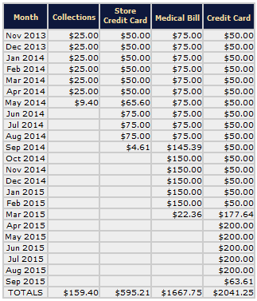

Snowball Benefits:
Interest Savings of $143.27!
Paid off
1 year & 8 months
sooner!

For a snowball calculator tool,
go to: www.powerpay.org
Also available to download in the app store

